**A**

**Synopsis Report On**

**Volume Unit (V U) meter**

***Submitted By-:***

**KUMAR ANIKET U101115FCS197 (S4)**

**GAURAV TIBREWAL U101115FCS088 (S3)**

**GULSHAN SINGH U101115FCS094 (S4)**

**Introduction to our idea**

Wewanted to make something that is really useful in our day to day life. We all know how much we listen to music every day so we came up with something which will give us a mesmerizing experience while listening to your favorite music.

We can consider the Volume Meter as an Equalizer, which is present in the Music systems. In which we can see the dancing of lights (LEDs) according to the music, if the music is loud, equalizer reaches to its peak and in low music it remains Low. We have also built a Volume Meter or VU meter, with the help of LM3914 IC, which glows the LEDs as per strength of the sound, if sound is low, lesser LEDs will glow, and if sound is High more LEDs will glow. VU meter serves as a volume measurement device.

LM3914 based LED VU Meter is very simple and effective. Looks great when in action. It runs from 9v to 12v power supply. So in Nutshell, when there is sound, the LM3914 comparator voltmeter glow the LEDs according to the strength to the given signal. Hence we have sound measuring instrument, and so VOLUME METER.

**LM3914 (10 bit Comparator based Led driver IC)**

The LM3914 is a monolithic integrated circuit that senses analog voltage levels and drives 10 LEDs, providing a linear analog display. A single pin changes the display from a moving dot to a bar graph. Current drive to the LEDs is regulated and programmable, eliminating the need for resistors. This feature is one that allows operation of the whole system from less than 3V.

The circuit contains its own adjustable reference and accurate 10-step voltage divider. The low-bias-current input buffer accepts signals down to ground, or V−, yet needs no protection against inputs of 35V above or below ground. The buffer drives 10 individual comparators referenced to the precision divider.

Indication non-linearity can thus be held typically to ½%, even over a wide temperature range.

Versatility was designed into the LM3914 so that controller, visual alarm, and expanded scale functions are easily added on to the display system. The circuit can drive LEDs of many colors, or low-current incandescent lamps. Many LM3914s can be chained” to form displays of 20 to over 100 segments. Both ends of the voltage divider are externally available so that 2 drivers can be made into a zero-center meter.

The LM3914 is very easy to apply as an analogmeter circuit. A 1.2V full-scale meter requires only 1 resistor and a single 3V to 15V supply in addition to the 10 display LEDs. If the 1 resistor is a pot, it becomes the LED brightness control. The simplified block diagram illustrates this extremely simple external circuitry,

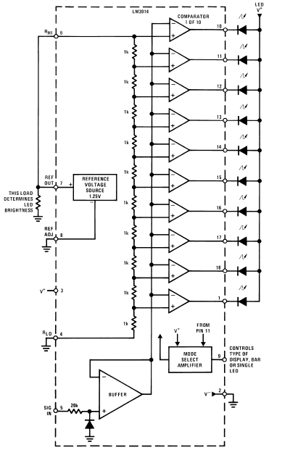

**Circuit Diagram**

The circuit diagram of the VU meter is show in below figure,

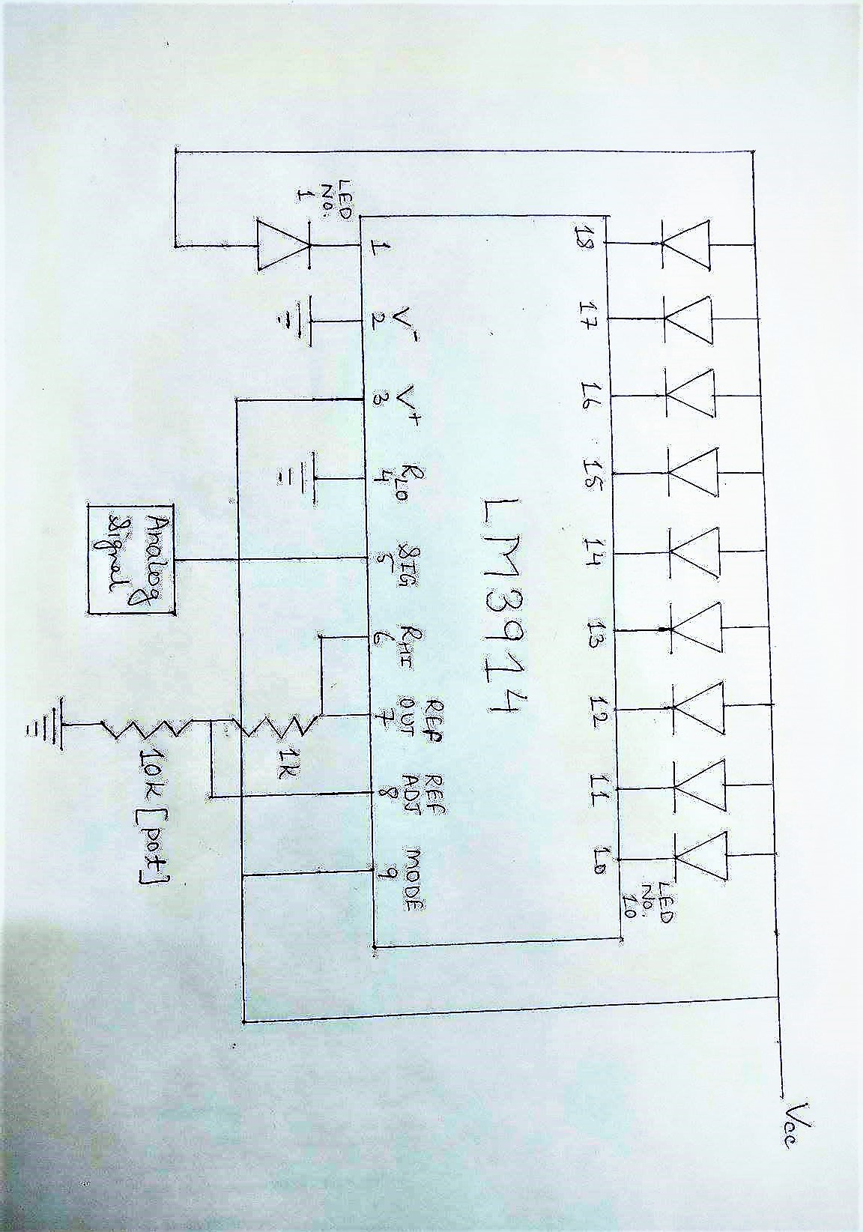

**Components Used**

* LEDs.
* LM3914 IC (10 bit comparator)**.**
* 1K resistor
* 10K pot.
* AUX wire.
* Female AUX port.
* 12V DC adaptor.
* Borosil glasses.
* General purpose board.
* Connecting wires.

**WORKING EXPLANATION:**

Working of VU meter Circuit is simple; at first we provide analog signal to pin no. 5 with the help of aux wire and female aux port. So for a higher sound we will have higher value and lower value for a lower sound. Then these voltages signals are fed to LM3914, which works as a voltmeter and glows LEDs according to the intensity of sound. Pin no. 4 is used to set reference low (which is generally grounded) and pin no. 6 is used for setting reference high. The voltage to pin no. 6 is provided by pin no. 7(ref out (reference voltage source 1.25V)) and a voltage divider circuit. Pin no. 8 is use to adjust the reference out voltage of pin no. 7.

LM3914 is a chip which drives 10 LED based on intensity of sound/voltage. The IC provides decimal outputs in the form of LED lighting based on the value of input voltage. The maximum measuring input voltage varies depending on reference voltage and supply voltage. This single chip device can be adjusted in a way, from which we can provide visual representation to the analog value of op-amp.

LM3914 is a 10stage voltmeter that means it shows variations in 10 bit mode. The chip senses the measuring input voltage as a parameter and compares it with reference. Say we choose a reference of “V”, now whenever the measuring input voltage rises by “V/10”, we have a LED of higher value glowing. Like if we gave “V/10”, LED1 will glow, if we gave “2V/10” LED2 will glow, if we gave “8V/10”, LED8 will glow. So greater the music volume, more the visual LED representation (more LED glows).

With a reference of 4V, every time there is an increment of 0.4V according to the sound intensity, the LED of high significance glows. The measuring level for LED goes as,

+0.4V, +0.8V, +1.2V, +1.6V, +2.0V, +2.4V, +2.8V, +3.2V, +3.6V, +4.0V.

**Applications**

.

* + 20-step meter with single pot brightness control.
  + Robot Battery meter.
  + 12V Car Battery Monitor.
  + Direction and rate indicator (to add to DVMs).
  + Temperature controlled kitchen exhaust fan.
  + Temperature meter circuit.
  + Lead-acid battery charge monitor.